First monopile installed at Harrow Bay Offshore Wind
Press release
Noah Fischer · 07 April 2026
Edinburgh, 7 April 2026 – Offshore construction at the 480 MW Harrow Bay Offshore Wind farm has begun. In the early hours of this morning the jack-up vessel MV Sea Atlas installed the first of 40 monopile foundations, 38 kilometres off the coast of Harrow Bay.
The monopile, manufactured by Rhenus Steelworks Foundations, is 9.5 metres in diameter and was driven into the seabed in a water depth of 31 metres. A double bubble curtain around the vessel reduced underwater noise during piling to protect harbour porpoises, and Marlow Ecology observers monitored the area before and during the work.
“Seeing the first foundation go in is a moment the whole team has worked towards for years,” said Felix Brandt, Offshore Construction Manager. “We will now install foundations in a steady rhythm from the Port of Eastholm, with safety and our environmental commitments always ahead of speed.”
The installation campaign will continue through 2026. The offshore substation is due to be installed in August, and the first Halden HTS-12 turbines are planned for spring 2027.
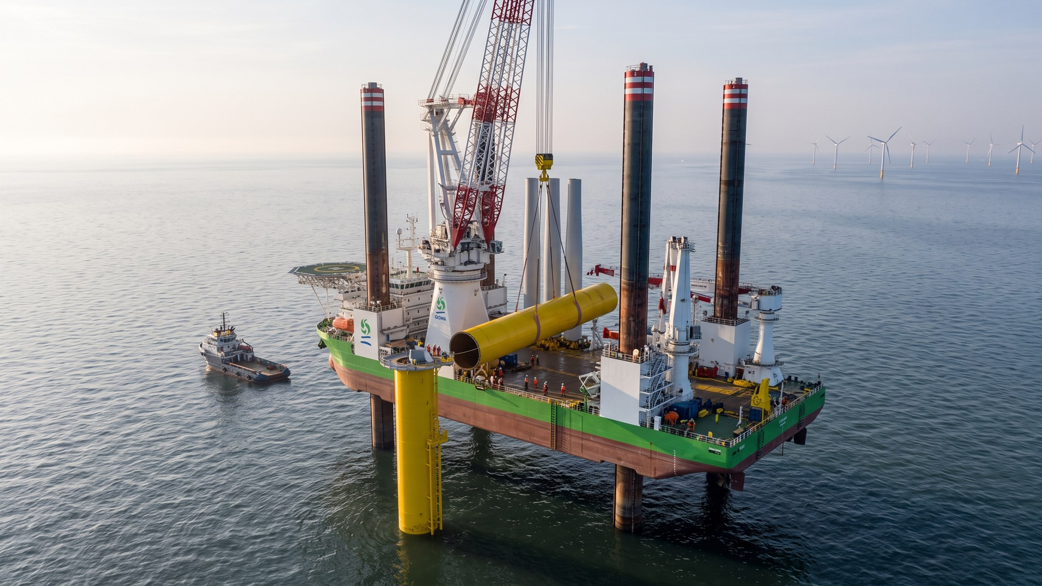
MV Sea Atlas installing the first monopile at Harrow Bay, 7 April 2026.
Media contact: Noah Fischer, Marketing & Communications Manager · press@weyland-energy.example · +49 40 3290 4410
About Weyland Energy. Weyland Energy GmbH develops, builds and operates wind, solar and storage assets across Northern Europe. Founded in 2011 and headquartered in Hamburg with offices in Edinburgh and Copenhagen, the company employs around 450 people, operates 1,100 MW of renewable capacity and has a development pipeline of 4.2 GW. In 2025 its assets avoided 1.2 million tonnes of CO₂. Clean power, built to last.

